Chapter 4, Problem 81.

For the circuit in Fig. 4.126, use PSpice to find the Thevenin equivalent at terminals a-b.

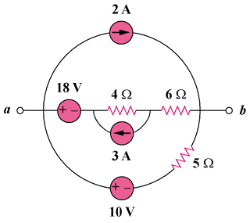

Figure 4.126
For Prob. 4.81.

